**Full Stack IV - Lab 1**

**●** ES6 Promises & Classes

**Developer Note:**

● Try to solve the problems without using search engines or stack overflow for the solutions. ● Create separate files for each exercise

**Exercise 1:**

● Using ES6 syntax for class and subclass using extends to create a Sedan subclass which derives from Car Class.

● The parameters for the Car class is the **model** and **year**. The parameters for the subclass are the **model, year and balance**.

● Use the super key word in the Sedan subclass to set the **model and name** in base Car constructor.

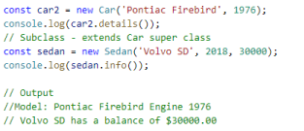

***ES6 Class and extends Reference***

<https://developer.mozilla.org/en-US/docs/Web/JavaScript/Reference/Classes/extends>  
**Exercise 2: - Promises**

* Write a function **compareNumToTen** that takes a number as an argument and returns a **Promise** that tests and rejects if the value is less than or resolves if greater than the value 10.

***Promise Reference***[**https://developer.mozilla.org/en-US/docs/Web/JavaScript/Reference/Global_Objects/Promise**](https://developer.mozilla.org/en-US/docs/Web/JavaScript/Reference/Global_Objects/Promise)

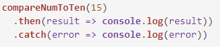

**Output**



**Exercise 3: - Promise.all**

* Use the **Promise.all** syntax to resolve all three promises below and return a new promise. Call the function and use the thenable .then() keyword to output the result.

***Promise.all() Reference***[**https://developer.mozilla.org/en-US/docs/Web/JavaScript/Reference/Global_Objects/Promise/all**](https://developer.mozilla.org/en-US/docs/Web/JavaScript/Reference/Global_Objects/Promise/all)

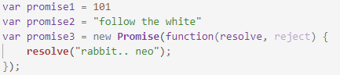

**Output**

* 